# Project 2- Attendance Management System Using Face Recognition.

Name- Khyati Jain

Problem Statement-

To develop an automated attendance management system using face recognition technology. The system aims to reduce manual errors, improve attendance accuracy, and ensure the authenticity of student/staff attendance in classrooms or workplaces.

Steps-

1. Data collection and preprocessing
2. Feature engineering
3. Model selection
4. Model training

Software Requirements-

1.Python should be installed .

2. Required Libraries-

1. tinker
2. tenserflow
3. 3.opencv-python
4. pillow
5. numpy

To install OpenCV ,PyTorch , TensorFlow, Keras , here are the following commands-

1.pip install opencv-python

2. pip install torch torchvision

3. pip install tensorflow

4.pip install keras

Here is the system architechture-

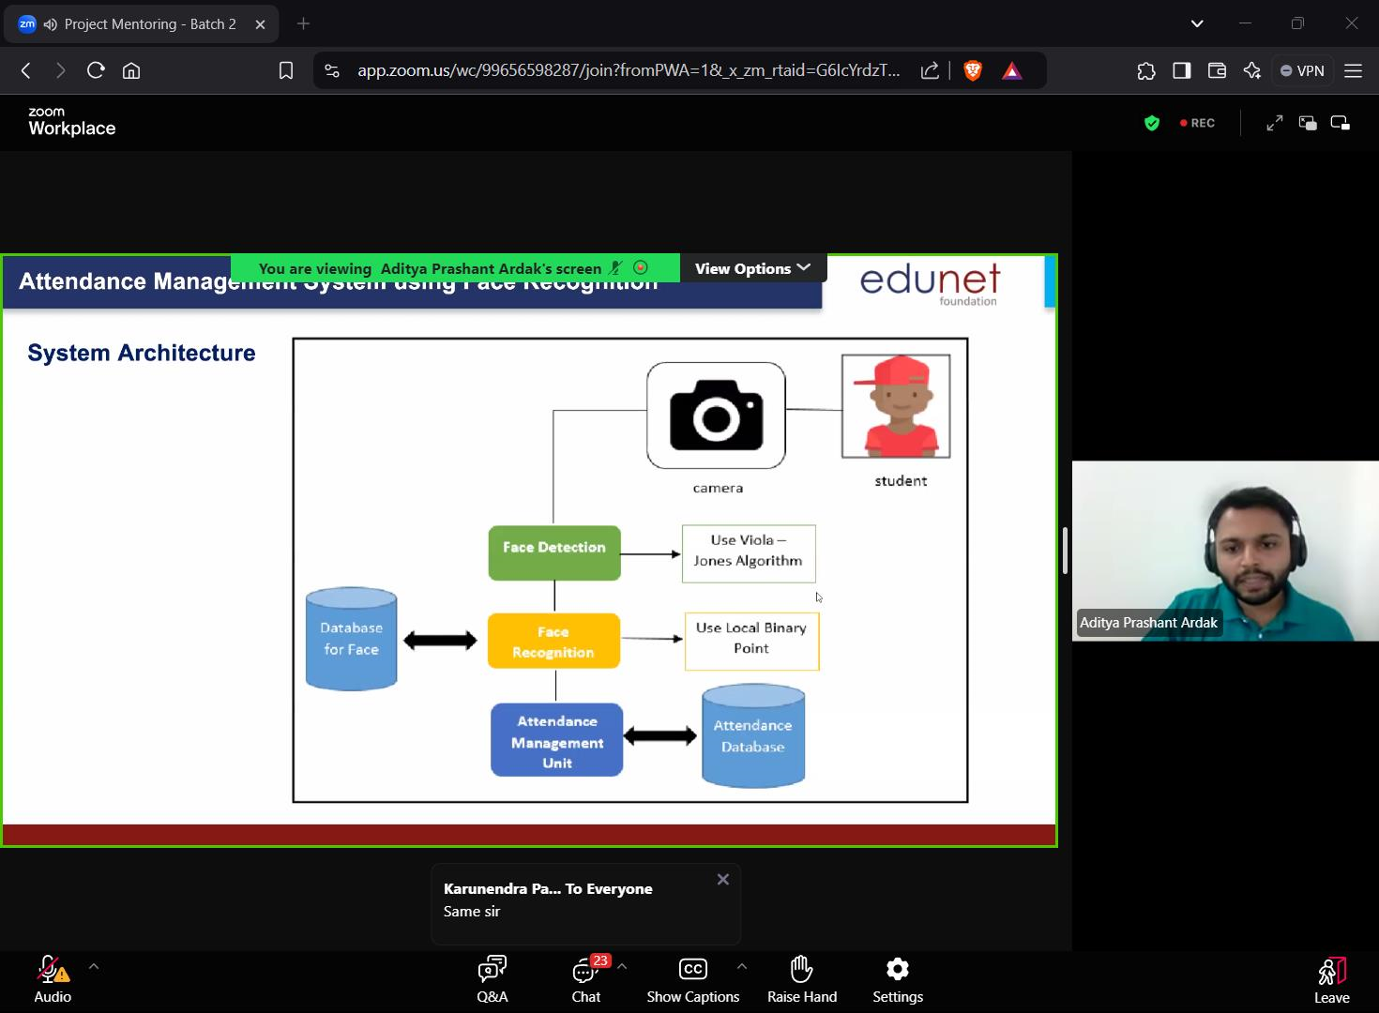

Here’s what we are going to do in this internship over the four weeks-

* Planning and Preparation
* Data Acquisition and Preprocessing
* Model building and Evaluation
* Deployment and Monitoring

Summary –

This is what I have learnt in the first session of this internship about the project. Basically, this is the overview of the project we are going to build in the following weeks. Hence, this is my summary of the first session of the program and all I have learnt and understood about the making of the project.

I believe to make an outstanding project under the guidance of the mentor and my hard work.

Thank You,

Khyati Jain